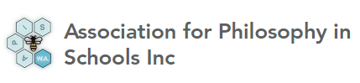
Announcement of Annual General Meeting
I hereby give notice that the Annual General Meeting will be held on Thursday 11th November 2021 in MLC boardroom at 7pm
The meeting will report on the work of APIS in 2021 and elect new Office bearers and committee for 2022.
There will be a presentation by Professor Stephan Millett entitled:
Can the NSW Primary Ethics program work with the WA Curriculum?
The Primary Ethics program in NSW is now more than a decade old and still going strongly.
It exists, in part, because NSW legislation mandates teaching of religious education in primary schools, but there was no formalised alternative for students whose families prefer that they not take part in school-based religious education.
The Primary Ethics program was developed by educators well versed in Philosophy in schools to be taught in the timetabled times set aside for religious education – as an option for students not taking part in RE. Both NSW Religious Education and Primary Ethics are taught by volunteers.
There are now discussions (and some preparatory work) on bringing the Primary Ethics program to WA. The proposal being discussed is to run a trial involving Year 5 students from a number of state schools and to engage university-based researchers to assess the trial. Recently, Stephan Millett was asked to map the Primary Ethics Stage 3 syllabus against both the curriculum for Year 5 in WA and the national General Capabilities.
This talk will show the extent to which the content and pedagogical approach of Primary Ethics intersects with outcomes in areas of the P-10 curriculum in WA. Discussion invited!
Professor Stephan Millett
Adjunct Professor, John Curtin Institute of Public Policy

Please RSVP (for catering purposes) to the Secretary Mr Oliver Keys: okeys@mlc.wa.edu.au

Election of APIS Office Bearers and Committee 2022
The positions for the APIS Office bearers and committee for 2022 will consist of the following:
Chair
Vice-Chair
Secretary
Treasurer
Marketing Officer
5 General Committee members

The rules of association state that to stand for a position of Office bearer or general committee member, a person must be nominated by another party, and must provide written acceptance of this nomination to the Secretary.
If nominations of all ten positions are received in advance of the meeting, then those nominated can be elected as one body at the meeting and no further nominations can be made on the night of the meeting.
If more than 10 people are nominated in advance of the meeting, then an election shall be held at the meeting
If less than 10 people are nominated in advance of the meeting, then further nominations can be made on the night of the meeting.
If you wish to nominate or be nominated for a position, please fill in the form below and return it to the Secretary

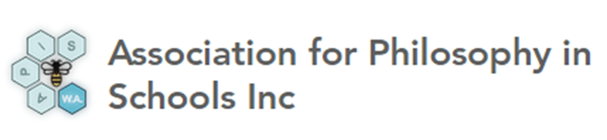
APIS Committee nomination form 2022

Position being nominated for

Nominated Person Signature

Nominator Signature

